Glossary of Public Administration Enterprise Architecture

Concept diagram

2025

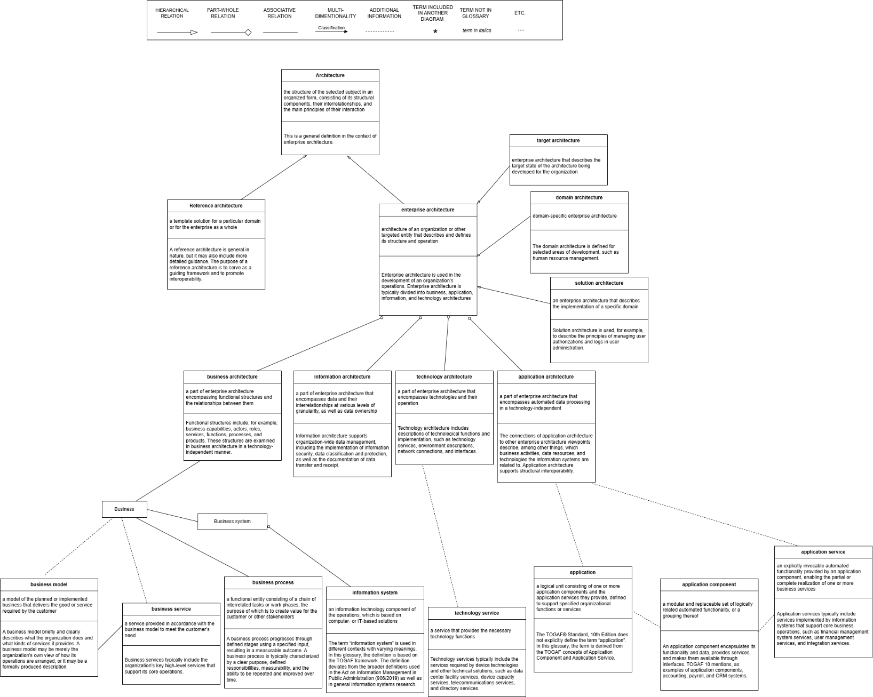
- Subtypes of architecture and enterprise architecture, as well as components of enterprise architecture and related concepts
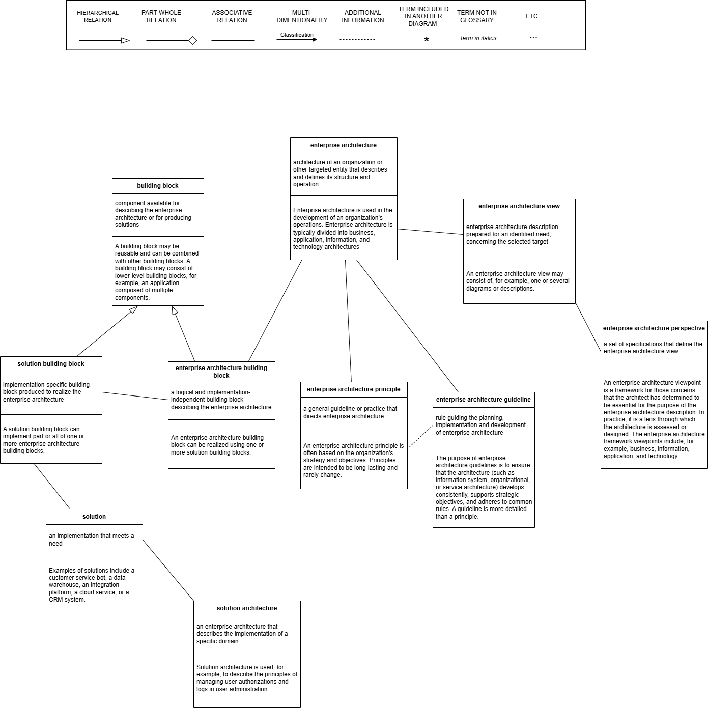
- Concepts Related to Enterprise Architecture, Part 1
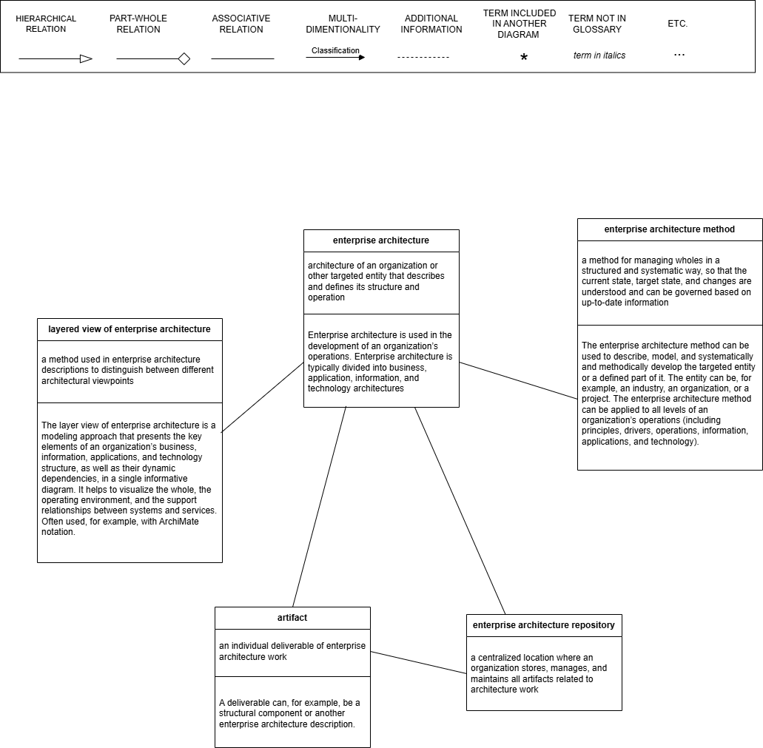
- Concepts Related to Enterprise Architecture, Part 2
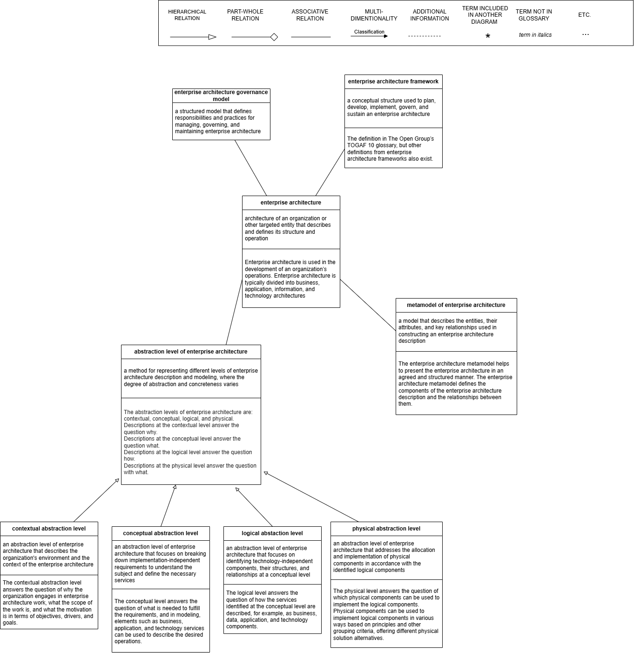
- Concepts and Levels of Abstraction Related to Enterprise Architecture

